Blinkit Analysis

- Create Table First:
- See all the data imported:
SELECT * FROM blinkit_data
- DATA CLEANING:
Cleaning the Item_Fat_Content field ensures data consistency and accuracy in analysis. The presence of multiple variations of the same category (e.g., LF, low fat vs. Low Fat) can cause issues in reporting, aggregations, and filtering. By standardizing these values, we improve data quality, making it easier to generate insights and maintain uniformity in our datasets.
UPDATE blinkit_data
SET Item_Fat_Content =
CASE
WHEN Item_Fat_Content IN ('LF', 'low fat') THEN 'Low Fat'
WHEN Item_Fat_Content = 'reg' THEN 'Regular'
ELSE Item_Fat_Content
END;

After executing this query check the data has been cleaned or not using below query
SELECT DISTINCT Item_Fat_Content FROM blinkit_data;

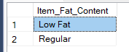

A. KPI’s
1. TOTAL SALES:
SELECT CAST(SUM(Total_Sales) / 1000000.0 AS DECIMAL(10,2)) AS Total_Sales_Million
FROM blinkit_data;
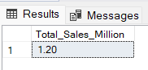
2. AVERAGE SALES
SELECT CAST(AVG(Total_Sales) AS INT) AS Avg_Sales
FROM blinkit_data;
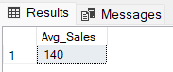
3. NO OF ITEMS
SELECT COUNT(*) AS No_of_Orders
FROM blinkit_data;
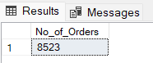
4. AVG RATING
SELECT CAST(AVG(Rating) AS DECIMAL(10,1)) AS Avg_Rating
FROM blinkit_data;
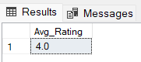

B. Total Sales by Fat Content:
SELECT Item_Fat_Content, CAST(SUM(Total_Sales) AS DECIMAL(10,2)) AS Total_Sales
FROM blinkit_data
GROUP BY Item_Fat_Content
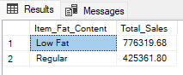

C. Total Sales by Item Type
SELECT Item_Type, CAST(SUM(Total_Sales) AS DECIMAL(10,2)) AS Total_Sales
FROM blinkit_data
GROUP BY Item_Type
ORDER BY Total_Sales DESC
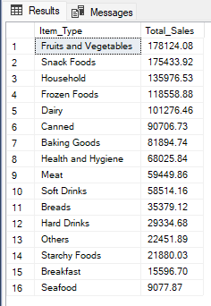
D. Fat Content by Outlet for Total Sales
SELECT Outlet_Location_Type,
COALESCE(
ROUND(SUM(
CASE
WHEN Item_Fat_Content = 'Low Fat' THEN Total_Sales
END)::numeric, 2), 0
) AS Low_Fat,
COALESCE(
ROUND(SUM(
CASE
WHEN Item_Fat_Content = 'Regular' THEN Total_Sales
END)::numeric, 2), 0
) AS Regular

FROM blinkit_data
GROUP BY Outlet_Location_Type
ORDER BY Outlet_Location_Type;
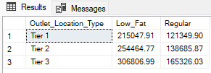
--Query Explanation
This query transforms the blinkit_data table to display total sales (Total_Sales) for each Outlet_Location_Type, split into two categories of Item_Fat_Content (“Low Fat” and “Regular”). This query uses conditional aggregation (CASE WHEN) to achieve the result.
If no sales exist for a category, the query returns 0 instead of NULL.
--Detailed Explanation:
--1. Aggregation with GROUP BY
SELECT
Outlet_Location_Type,
Purpose: Groups the dataset by Outlet_Location_Type
Each row in the result represents one location type (e.g., Tier 1, Tier 2, Tier 3)
--2. Conditional Aggregation using CASE WHEN
Low Fat Column
SUM(CASE
WHEN Item_Fat_Content = 'Low Fat' THEN Total_Sales
END)
Purpose: Filters and sums only the sales where Item_Fat_Content = 'Low Fat'
If the condition is not met → returns NULL
SUM() ignores NULL values → only valid rows are summed
Regular Column
SUM(CASE
WHEN Item_Fat_Content = 'Regular' THEN Total_Sales
END)
Works the same way as above, but for Regular items
--3. Data Type Conversion
::numeric
Converts the result into a numeric data type
Required because PostgreSQL ROUND() works best with numeric values
--4. Formatting using ROUND
ROUND(..., 2)
Rounds the aggregated value to 2 decimal places
Ensures consistency in financial reporting
--5. Handling NULL Values using COALESCE
COALESCE(..., 0)
Replaces NULL values with 0
Ensures that if no sales exist for a category, the output shows 0 instead of NULL
--6. Final Column Aliases
AS Low_Fat,
AS Regular
Renames the columns for better readability
--7. Sorting the Output
ORDER BY Outlet_Location_Type;
Sorts the final result alphabetically by Outlet_Location_Type
--Why Use COALESCE? When using conditional aggregation:
If no rows match the condition → result is NULL
COALESCE(..., 0) ensures:
Cleaner output, Better readability, Useful for dashboards and reports
--Key Concept Used
--This approach is called Conditional Aggregation (Manual Pivoting)

E. Total Sales by Outlet Establishment
SELECT Outlet_Establishment_Year, CAST(SUM(Total_Sales) AS DECIMAL(10,2)) AS Total_Sales
FROM blinkit_data
GROUP BY Outlet_Establishment_Year
ORDER BY Outlet_Establishment_Year
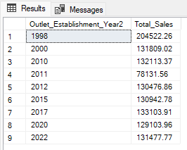

F. Percentage of Sales by Outlet Size
SELECT
Outlet_Size,
CAST(SUM(Total_Sales) AS DECIMAL(10,2)) AS Total_Sales,
CAST((SUM(Total_Sales) * 100.0 / SUM(SUM(Total_Sales)) OVER()) AS DECIMAL(10,2)) AS Sales_Percentage
FROM blinkit_data
GROUP BY Outlet_Size
ORDER BY Total_Sales DESC;

Query Explanation:
Outlet_Size: This column represents the size category of the outlet (e.g., Small, Medium, Large).
CAST(SUM(Total_Sales) AS DECIMAL(10,2)) AS Total_Sales:
- SUM(Total_Sales): Calculates the total sales for each Outlet_Size.
- CAST(... AS DECIMAL(10,2)): Formats the resulting sum to a decimal number with two decimal places for precision.
CAST((SUM(Total_Sales) * 100.0 / SUM(SUM(Total_Sales)) OVER()) AS DECIMAL(10,2)) AS Sales_Percentage:
- SUM(Total_Sales) * 100.0: Multiplies the total sales of the current Outlet_Size by 100 to prepare for percentage calculation.
- SUM(SUM(Total_Sales)) OVER():
  - SUM(Total_Sales): Within the GROUP BY context, this computes the total sales for each Outlet_Size.
  - SUM(... ) OVER(): The outer SUM combined with the OVER() clause calculates the grand total of all Total_Sales across all outlet sizes without collapsing the result set.
- SUM(Total_Sales) * 100.0 / SUM(SUM(Total_Sales)) OVER(): Divides the total sales of the current Outlet_Size by the grand total sales and multiplies by 100 to get the percentage contribution of each outlet size to the overall sales.
- CAST(... AS DECIMAL(10,2)): Formats the resulting percentage to two decimal places.

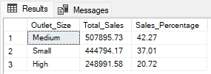

G. Sales by Outlet Location
SELECT Outlet_Location_Type, CAST(SUM(Total_Sales) AS DECIMAL(10,2)) AS Total_Sales
FROM blinkit_data
GROUP BY Outlet_Location_Type
ORDER BY Total_Sales DESC
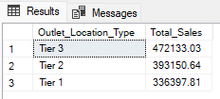

H. All Metrics by Outlet Type:
SELECT Outlet_Type,
CAST(SUM(Total_Sales) AS DECIMAL(10,2)) AS Total_Sales,
CAST(AVG(Total_Sales) AS DECIMAL(10,0)) AS Avg_Sales,
COUNT(*) AS No_Of_Items,
CAST(AVG(Rating) AS DECIMAL(10,2)) AS Avg_Rating,
CAST(AVG(Item_Visibility) AS DECIMAL(10,2)) AS Item_Visibility
FROM blinkit_data
GROUP BY Outlet_Type
ORDER BY Total_Sales DESC

